 



Database Programming with SQL 6-3: Inner versus Outer Joins Practice Activities

# Objectives

* Compare and contrast an inner and an outer join
* Construct and execute a query to use a left outer join
* Construct and execute a query to use a right outer join
* Construct and execute a query to use a full outer join

# Vocabulary

Identify the vocabulary word for each definition below.

|  |  |
| --- | --- |
| **FULL OUTER JOIN** | Performs a join on two tables, retrieves all the rows in the Left table, even if there is no match in the Right table. It also retrieves all the rows in the Right table, even if there is no match in the Left table. |
| **outer join** | A join that returns the unmatched rows as well as matched rows |
| **LEFT OUTER JOIN** | Performs a join on two tables, retrieves all the rows in the Left table even if there is no match in the Right table. |
| **RIGHT  OUTER JOIN** | Performs a join on two tables, retrieves all the rows  in the Right table even if there is no match in the Left table. |
| **INNER JOIN** | A join of two or more tables that returns only matched rows |

# Try It / Solve It

Use the Oracle database for problems 1-7.

1. Return the first name, last name, and department name for all employees including those employees not assigned to a department.

**SELECT  emp.first_name "First Name", emp.last_name "Last Name" , dpt.department_name  "Department Name"**

**FROM  employees emp LEFT OUTER JOIN departments dpt ON emp.department_id = dpt.department_id;**

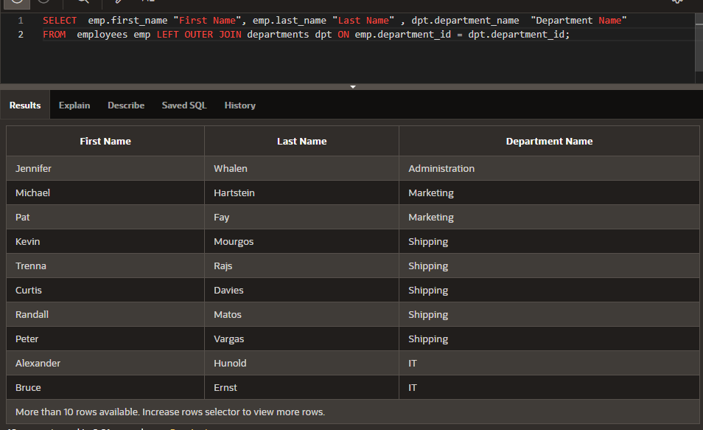

1. Return the first name, last name, and department name for all employees including those departments that do not have an employee assigned to them.

**SELECT  emp.first_name "First Name", emp.last_name "Last Name" , dpt.department_name  "Department Name"**

**FROM  employees emp RIGHT OUTER JOIN departments dpt ON emp.department_id = dpt.department_id;**

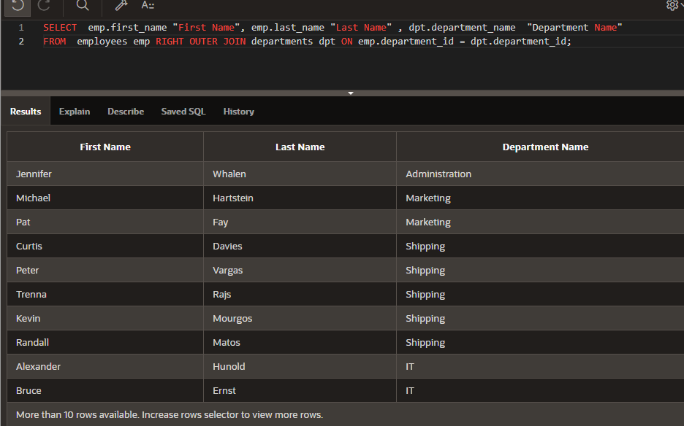

1. Return the first name, last name, and department name for all employees including those departments that do not have an employee assigned to them and those employees not assigned to a department.

**SELECT  emp.first_name "First Name", emp.last_name "Last Name" , dpt.department_name  "Department Name"**

**FROM  employees emp FULL OUTER JOIN departments dpt ON emp.department_id = dpt.department_id;**

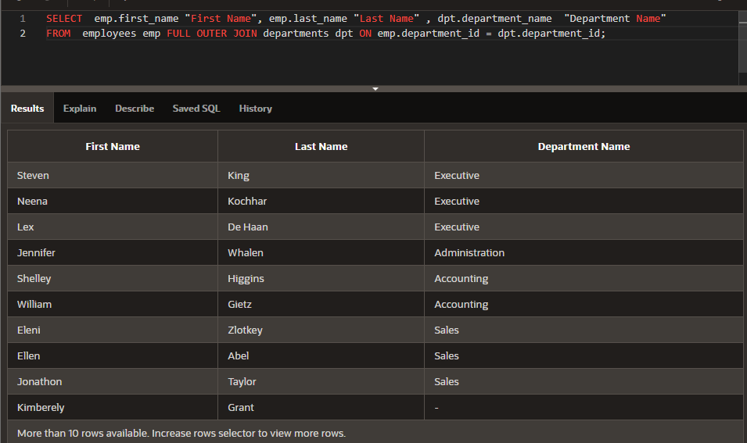

1. Create a query of the DJs on Demand database to return the first name, last name, event date, and description of the event the client held. Include all the clients even if they have not had an event scheduled.

**SELECT ct.first_name, ct.last_name, ev.event_date, ev.description**

**FROM  d_clients ct LEFT OUTER JOIN d_events ev ON ct.client_number = ev.client_number;**

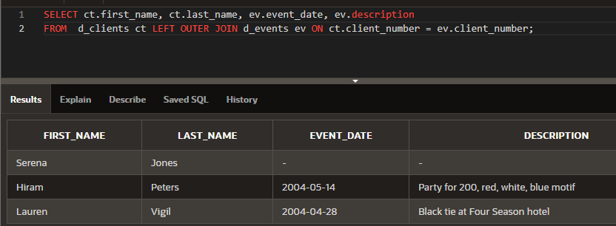

1. Using the Global Fast Foods database, show the shift description and shift assignment date even if there is no date assigned for each shift description.

**SELECT f_shifts.description "shift description", f_shift_assignments.shift_assign_date AS "shift assignment date"**

**FROM  f_shifts LEFT OUTER JOIN f_shift_assignments ON f_shifts.code = f_shift_assignments.code;**

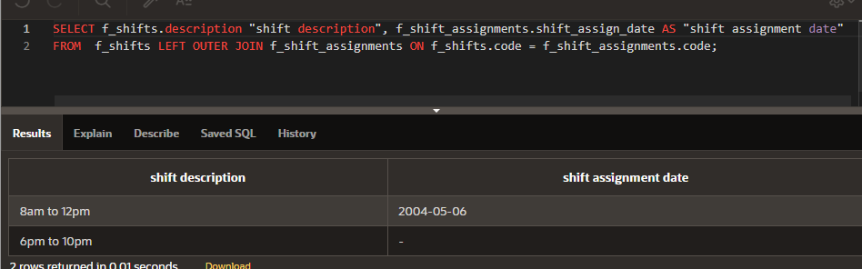

Copyright © 2020, Oracle and/or its affiliates. All rights reserved. Oracle and Java are registered trademarks of Oracle and/or its affiliates. Other names may be trademarks of their respective owners.